# Exploring the Influence of Coping Strategies and Spirituality on Mental Health in Pregnant Women

This reports the findings of a survey research study to show the interactions between coping mechanisms, spirituality, and postnatal outcomes among expectant mothers. The multiple regression analysis explores what predictive effects coping mechanisms and spiritual beliefs can have on maternal well-being concerning prenatal stress. This study reveals strong relationships between coping mechanisms and maternal well-being, where adaptive strategies correlate with lower rates of postnatal depression (PND), while maladaptive ones involve increased distress. Further, it is anticipated that spirituality will mediate this relationship such that higher levels of coping effectively through effective postnatal outcomes. Controlling prenatal distress will make our understanding of these dynamics better. This research was designed to explore the impact of coping strategies and spiritual beliefs on pregnant women’s mental health during a perinatal period that can help suggest appropriate interventions for expectant mothers to deprive them of developing PND.

Some variables in the dataset are WHO_QOL_BREF, a short form used for the World Health Organization Quality of Life scale overall quality of life, Edinburgh_PDS stands for depiction that measures symptoms postpartum, providing evidence related to depression after pregnancy results. NuPDQ represents Revised Prenatal Distress Questionnaire, NuPCI_total represents Revised Prenatal Coping Inventory total, NuPCI_plan_prep represents Revised Prenatal Coping Inventory Plan Preparation, NuPCI_avoid represents Revised Prenatal Coping Inventory Avoid, BMMRS represents Brief Multidimensional Measurement of Religiousness/Spirituality, BMMRS_Intrinsic represents Brief Multidimensional Measurement of Religiousness/Spirituality Intrinsic, and BMMRS_Extrinsic represents Brief Multidimensional Measurement of Religiousness/Spirituality Extrinsic.

This chapter provides a systematic way of interpreting the data and testing the postulated hypothesis regarding how coping strategies and spirituality influence mental health in pregnant women during their perinatal stages. It starts with frequency tables describing features of the study sample. Afterward, correlation analysis and multiple regression modeling are performed to evaluate variable relationships as well as the accuracy of prediction. The chapter uses multiple regression model assessments, including model summary, ANOVA, model coefficients, correlation and covariance analysis, multicollinearity diagnostics, residual analysis, and normality assumption testing to interpret the data further. In the end, a summary of the results concludes with an attempt to synthesize findings and their implications for understanding postnatal depression risk in expectant mothers.

## Descriptive Statistics

Descriptive statistics explores the data for the distribution and characteristics of the variables included in the analysis. Each variable, including the revised prenatal distress questionnaire, revised prenatal coping inventory avoid, revised prenatal coping inventory plan preparation, revised prenatal coping inventory avoid, brief multidimensional measurement of religiousness/spirituality, brief multidimensional measurement of religiousness/spirituality intrinsic, and brief multidimensional measurement of religiousness/spirituality extrinsic, contributes valuable information about prenatal distress, coping strategies, and spirituality as measured by the respective instruments.

**Table 1**

*Descriptive statistics*

|  |  |  |  |  |
| --- | --- | --- | --- | --- |
| Variable | N | Mean | Median | sd |
| WHO_QOL_BREF | 95 | 27.24 | 27 | 2.77 |
| Edinburgh_PDS | 95 | 92.42 | 92 | 10.76 |
| NuPDQ | 95 | 43.63 | 45 | 9.22 |
| NuPCI_total | 95 | 106.90 | 106 | 11.22 |
| NuPCI_plan_prep | 95 | 65.59 | 64 | 8.87 |
| NuPCI_avoid | 95 | 34.69 | 36 | 8.04 |
| BMMRS | 95 | 90.07 | 90 | 30.73 |
| BMMRS_Intrinsic | 95 | 55.56 | 53 | 23.01 |
| BMMRS_Extrinsic | 95 | 34.51 | 37 | 8.76 |

WHO_QOL_BREF =World Health Organization Quality of Life scale, brief version, Edinburgh_PDS =Edinburgh Postnatal Depression Scale, NuPDQ=Revised Prenatal Distress Questionnaire, NuPCI_total=Revised Prenatal Coping Inventory total, NuPCI_plan_prep=Revised Prenatal Coping Inventory Plan Preparation, NuPCI_avoid=Revised Prenatal Coping Inventory Avoid, BMMRS=Brief Multidimensional Measurement of Religiousness/Spirituality, BMMRS_Intrinsic=Brief Multidimensional Measurement of Religiousness/Spirituality Intrinsic, and BMMRS_Extrinsic=Brief Multidimensional Measurement of Religiousness/Spirituality Extrinsic

The mean Revised Prenatal Distress Questionnaire score was 43.63, equivalent to moderate prenatal distress for participants in pregnancy. The standard deviation of 9.23 shows variation in the participants’ levels of subjective distress. Among the Revised Prenatal Coping Inventory Total, the mean score for subjects was 106.90, indicating overall types of coping mechanisms during pregnancy with a standard deviation of 11.22. Participants scored 65.59 in the Revised Prenatal Coping Inventory Plan Preparation, where their median value was 64, and this implies that during pregnancy, they used moderate levels of plan prep coping strategies with a variance of 8.87 showing variability in scores hence different usage patterns for these strategies.

The Revised Prenatal Coping Inventory Avoid subscale scores represented an average score of 34.69, indicating how much respondents used avoidance coping techniques during their pregnancy periods. In comparison to the mean, a standard deviation of 8.042 means that scores are distributed in different levels from participant to participant while working with avoidance coping; as for transition to spirituality measures, participants scored 90.7 on brief multidimensional measurement of religiousness/spirituality, which represents general level religiousness and spiritualism form all religions type; Considered The values measure variability between persons.

## Variables of Interest

**Figure 1**

Edinburgh Postnatal Depression Scale

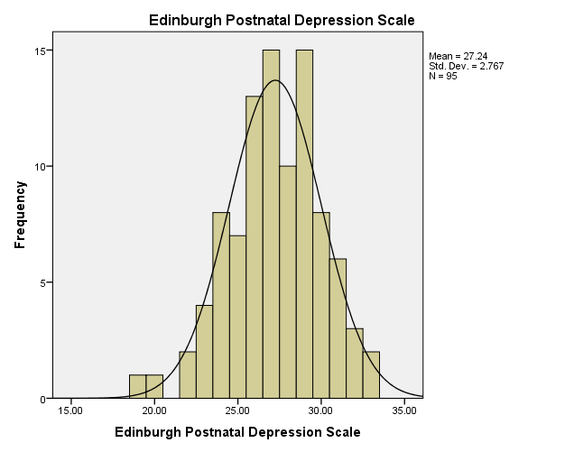

The bell curve of the EPDS variable is symmetrical, as shown above, which shows that it follows a normal distribution. However, this implies that the data points are average, around the mean, with most values grouped at both edges tapering towards extremes. The mean value of the EPDS variable is 27, which signifies an average score on the depreciation scale, and for standard deviation, 2.767. A smaller value implies scores closer to the means and higher values for highly variant or dispersed scores.

**Figure 2**

World Health Organization Quality of Life scale

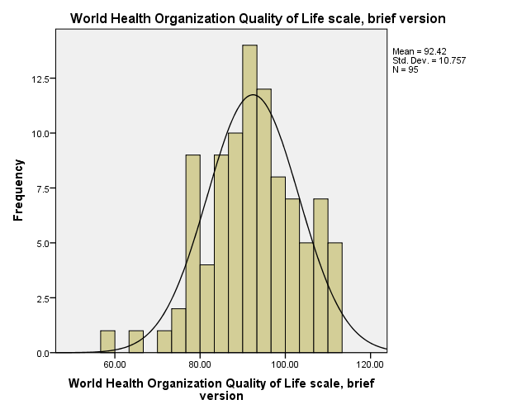

In the World Health Organization quality of life scale distribution, most data points lie close to the center and gradually fade into the peripheries’ ends. The mean score for the World Health Organization Quality of Life scale brief index scores is 92.42, which reflects an average quality of life among individuals in this study and a standard deviation of 10.76. The one with a smaller standard deviation tends towards the mean, while the other with more variations of scores is higher.

## Inferential Statistics

**Table 2**

Correlation

|  |  |  |  |  |  |  |  |  |  |
| --- | --- | --- | --- | --- | --- | --- | --- | --- | --- |
| Variables | a | b | c | | d | e | f | g | h |
| a.WHO_QOL_BREF |  |  |  | |  |  |  |  |  |
| b. Edinburgh_PDS | .554** |  |  | |  |  |  |  |  |
| c. NuPDQ | -.309** | -.207* | |  |  |  |  |  |  |
| d. NuPCI_total | .017 | -.195 | .391** | |  |  |  |  |  |
| e. NuPCI_plan_prep | .372** | .094 | .085 | | .707** |  |  |  |  |
| f. NuPCI_avoid | -.378** | -.348** | .447** | | .590** | -0.141 |  |  |  |
| g. BMMRS | .077 | .278** | -.005 | | -.349** | -.206* | -.260* |  |  |
| h. BMMRS_Intrinsic | .066 | .266** | -.036 | | -.382** | -.247* | -.257* | .982** |  |
| i. BMMRS_Extrinsic | .113 | .272** | .038 | | -.230* | -.087 | -.233* | .926** | .848** |

WHO_QOL_BREF =World Health Organization Quality of Life scale, brief version, Edinburgh_PDS =Edinburgh Postnatal Depression Scale, NuPDQ=Revised Prenatal Distress Questionnaire, NuPCI_total=Revised Prenatal Coping Inventory total, NuPCI_plan_prep=Revised Prenatal Coping Inventory Plan Preparation, NuPCI_avoid=Revised Prenatal Coping Inventory Avoid, BMMRS=Brief Multidimensional Measurement of Religiousness/Spirituality, BMMRS_Intrinsic=Brief Multidimensional Measurement of Religiousness/Spirituality Intrinsic, and BMMRS_Extrinsic=Brief Multidimensional Measurement of Religiousness/Spirituality Extrinsic

The World Health Organization Quality of Life scale, abbreviated version (WHO_QOL_BREF), is connected to various psychological scores by significant correlations. More specifically, WHO_QOL_BREF has a positive relationship with the Edinburgh Postnatal Depression Scale (Edinburgh_PDS) (r = 0.554 p < .01), so higher scores in perceived quality of life show more postnatal depressive symptoms are present. Moreover, WHO_QOL_BREF is negatively related to the Revised Prenatal Coping Inventory Avoid (r=.378, p < .01). Furthermore, WHO_QOL_BREF shows positive relations with several dimensions of religiousness/spirituality (from r = 0.077 to r = 0.113). An opposite trend exists for the Edinburgh_PDS, which measures postnatal depression; it correlates positively with WHO_QOL_BREF (r = 0.554 p>01), suggesting that a higher level of quality of life is associated with increased depressive symptoms.

There is a negative correlation between subscales of the Revised Prenatal Coping Inventory and Edinburgh postnatal distress, including Total coping Strategies (r=-.195, p< .05) and plan Preparation (r = -.348, p <.01). The Prenatal Distress Questionnaire, in its revised version, exhibits a positive correlation with the total of Revised Inventory at p < .01 (r = .39), demonstrating that higher levels of distress during pregnancy correspond to increased coping efforts In addition, the Revised Prenatal Coping Inventory total scores show a positive correlation with its components namely Plan Preparation (r=.707, p< .01) and Avoidance( r = .447, p < .01), which marks their interrelations between different coping mechanisms to stress. In particular, positive correlations between Brief Multidimensional Measurements of Religiousness/Spirituality Intrinsic and Extrinsic (r = .848, p < .01).

## Regression I

**Table 3**

*Model Summary*

|  |  |  |  |
| --- | --- | --- | --- |
| Model | R | R Square | Adjusted R Square |
| 1 | .37a | .14 | .11 |

The model significance reflects that the entire model is significant in predicting variables. In this case, the R square value of 0.11 means a 11% variance in the World Health Organization quality of life scale, the brief version due to predictors present within the model.

**Table 4**

ANOVA

|  |  |  |  |  |  |  |
| --- | --- | --- | --- | --- | --- | --- |
| Model |  | Sum of Squares | df | Mean Square | F | Sig. |
| 1 | Regression | 1501.10 | 3 | 500.38 | 4.86 | .004b |
|  | Residual | 9375.10 | 91 | 103.02 |  |  |

The ANOVA table for the regression model indicates very significant results (p< 0.01), reflecting a strong relationship between predictors and the dependent variable. The F-test statistic is 4.86, with 3 and 91 degrees of freedom. The sum of squares for regression amounts to 1501.10. The mean square for regression, 500.38, refers to the average variance explained by each predictor. In contrast, the sum of squares for residuals is 9375.10, representing a total amount of unexplained variability in terms of the variation on the dependent variable. The mean square for residuals, which is 103.02, suggests the average unexplained variation per observation of this data set.

**Table 5**

Model coefficients and collinearity

|  |  |  |  |  |  |  |
| --- | --- | --- | --- | --- | --- | --- |
| Model |  | Unstandardized Coefficients | | Standardized Coefficients | Sig. | Collinearity Statistics |
|  |  | B | Std. Error | Beta |  | VIF |
| 1 | (Constant) | 84.61 | 12.22 |  | 0.00 |  |
|  | NuPDQ | -0.46 | 0.13 | -0.39 | 0.00 | 1.21 |
|  | NuPCI_total | 0.22 | 0.11 | 0.22 | 0.05 | 1.37 |
|  | BMMRS | 0.05 | 0.04 | 0.15 | 0.14 | 1.16 |

NuPDQ=Revised Prenatal Distress Questionnaire, NuPCI_total=Revised Prenatal Coping Inventory total, BMMRS=Brief Multidimensional Measurement of Religiousness/Spirituality

Using regression analysis, some important coefficients were determined to evaluate the impact of predictors on the World Health Organization’s Quality of Life Scale, brief version. Of the predictors, there was a significant negative relationship between the World Health Organization quality of life scale, brief version, and Revised Prenatal Distress Questionnaire (β = -.39, p= .00), indicating a continuous decrease in prenatal distress during pregnancy. The revised prenatal coping inventory total has a coefficient of .22 with a p=0.05 indicating a significance positive effect to the WHO_QOL_BREF.

The Variance Inflation Factor (VIF) values determine collinearity among the predictor variables in the regression model. They also show the amount of correlation between each predictor variable and others. A VIF value over ten is usually considered a high multicollinearity level, indicating strong interrelation among predictor variables. Thus, the Revised Prenatal Distress Questionnaire, revised prenatal coping inventory total and Brief Multidimensional Measurement of Religiousness/Spirituality has VIF values of 1.21, 1.37 and 1.16 respectively, implying low Multicollinearity.

**Figure 3**

Regression standardized residuals

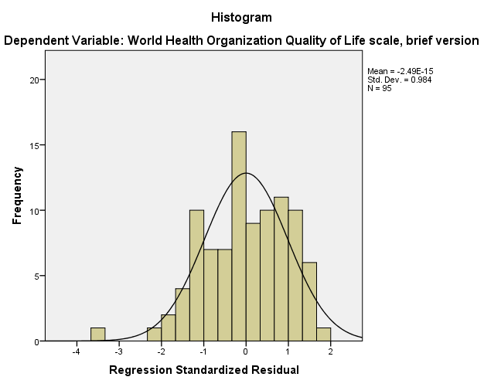

The histogram above shows the standardized residuals of the Brief version of the World Health Organization Quality of Life. The histogram is symmetric and evenly distributed around 0 indicating normality assumption to be true.

**Figure 4**

Normal P-P Plot

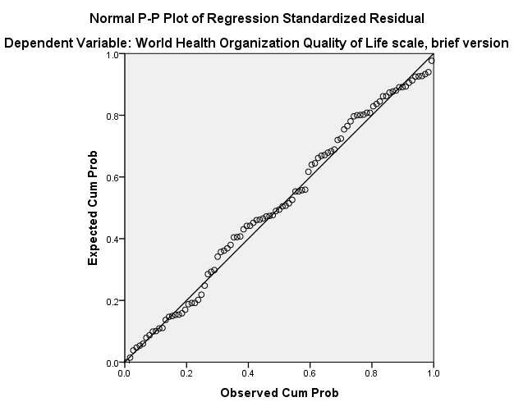

The Normal P-P plot of regression standardized residuals offers information regarding the distribution of residuals of the model. The plot reveals that the residuals nearly follow a straight line, evidencing compliance with normal distribution. This means that the residuals replicate as predicted from a normal population and confirm the normality assumption of regression model. The normal distributions of residuals further validate regression analysis findings and are assumed to suggest positive correlations between predictors and dependent variables within this model.

## Regression II

**Table 9**

Model Summary

|  |  |  |
| --- | --- | --- |
| Model | R Square | Adjusted R Square |
| 1 | .12 | .09 |

Fit and explanatory power are some model indicators adjusted R-squared, presented by a percentage measure where different independent variables could account for variance with respect to dependent variables after adjusting on number predictors. In the model forecasting Edinburgh Postnatal Depression Scale (Edinburgh Postnatal Depression Scale) scores, an adjusted R-squared value of .09 would indicate that about 9% variability in postpartum depression can be explained by predictors.

**Table 10**

ANOVA

|  |  |  |  |  |  |  |
| --- | --- | --- | --- | --- | --- | --- |
| Model |  | Sum of Squares | Df | Mean Square | F | Sig. |
| 1 | Regression | 85.74 | 3 | 28.56 | 4.10 | .009b |
|  | Residual | 633.69 | 91 | 6..96 |  |  |

The significance of the regression model predicting Edinburgh Postnatal Depression Scale (Edinburgh Postnatal Depression Scale) scores is evaluated through an analysis of variance (ANOVA). The results indicate that the regression model as a whole is statistically significant (F(3, 91) = 4.10, p = .009), as evidenced by a significant regression sum of squares (85.74) compared to the residual sum of squares (633.69). This suggests that the independent variables collectively contribute to explaining the variance in postnatal depression scores. The significant p-value (p = .009) further confirms that the model’s explanatory power is not due to random chance, indicating that the included predictors - Brief Multidimensional Measurement of Religiousness/Spirituality, Revised Prenatal Distress Questionnaire, and Revised Prenatal Coping Inventory Total - jointly contribute to predicting Edinburgh Postnatal Depression Scale scores significantly above the baseline.

**Table 11**

Model Coefficients and Collinearity

|  |  |  |  |  |  |  |
| --- | --- | --- | --- | --- | --- | --- |
| Model |  | Unstandardized Coefficients | | Standardized Coefficients | Sig. | Collinearity Statistics |
|  |  | B | Std. Error | Beta |  | VIF |
| 1 | (Constant) | 28.30 | 3.18 |  | 0.00 |  |
|  | NuPDQ | -0.06 | 0.03 | -0.19 | 0.08 | 1.21 |
|  | NuPCI_total | -0.01 | 0.03 | -0.03 | 0.82 | 1.37 |
|  | BMMRS | 0.02 | 0.01 | 0.27 | 0.01 | 1.16 |

NuPDQ=Revised Prenatal Distress Questionnaire, NuPCI_total=Revised Prenatal Coping Inventory total, BMMRS=Brief Multidimensional Measurement of Religiousness/Spirituality

The regression analysis examining predictors of Edinburgh Postnatal Depression Scale scores yielded several notable findings. Only one predictor variables emerged as statistically significant in predicting postnatal depression severity. Brief Multidimensional Measurement of Religiousness/Spirituality (Beta = .27, p = .0.01) demonstrated significant association with postnatal depression scores. Specifically, for every one-unit increase in Brief Multidimensional Measurement of Religiousness/Spirituality, there was a corresponding increase of approximately .27 units in Edinburgh Postnatal Depression Scale scores. However, the remaining predictor variables, including Revised Prenatal Distress Questionnaire and Revised Prenatal Coping Inventory total did not demonstrate statistically significant relationships with Edinburgh Postnatal Depression Scale scores in this model.

The VIF values are considered to test for Multicollinearity among the predictor variables. This model reveals the Revised Prenatal Distress Questionnaire, Brief Multidimensional Measurement of Religiousness/Spirituality, and Revised Prenatal Coping Inventory total VIF values of 1.21, 1.16, and 1.37 respectively indicating low levels of Multicollinearity.

**Figure 5**

Standardized residual distribution

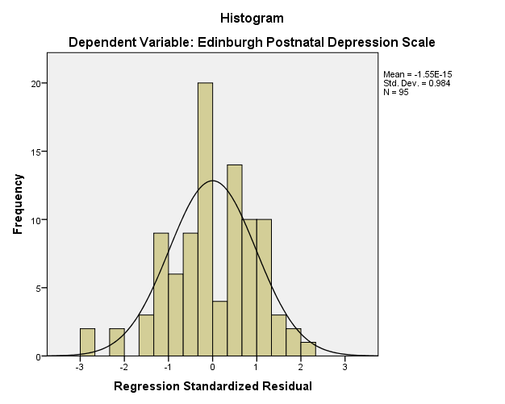

The histogram above shows the distribution of standardized residuals of the Edinburgh postnatal depression. The histogram is symmetric and evenly distributed around 0 indicating normality assumption to be true.

**Figure 6**

Normal P-P plot

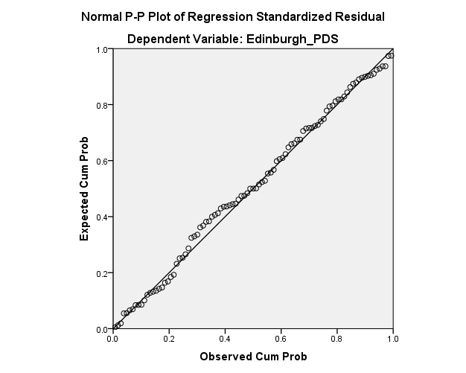

Normal P-P plot of regression standardized residuals offers inferentially relevant information regarding the normality assumption for the model variable. The plots shows that the residuals are as close to the diagonal line as possible, which means a high normality distribution dedication. This indicates that residuals look like what should be expected in a normal population, thus confirming the normality assumption of the regression model for the Edinburgh Postnatal Depression Scale. The degree of normality in the distribution between residuals adds a little to the reliability of how a good model captures relationships and patterns in the Edinburgh Postnatal Depression Scale variable versus predictor variables.

## Summary

Regression analysis was conducted in this chapter to address the predictors of postnatal depression severity measured using the Edinburgh Postnatal Depression Scale (Edinburugh_PDS) and World Health Quality of Life, brief version (WHO_QOL_Bref). The first model accounted for 9% f the variance in Edinburgh Postnatal Depression Scale scores, with BMMRS as a significant predictor. In comparison, the other model accounted for 11% of the variance in World Health Organization Quality of Life brief scale with NuPDQ and NuPCI_total as significant predictors. The Multicollinearity among predictors was identified using the variance inflation factor (VIF) for all the predictors in the model, which may affect the reliability of regression coefficients. The reliability of the regression models was validated by normality testing, linearity testing, independence, and homoscedasticity.

Although this research has contributed to the overall goal of revealing how coping strategies and spirituality affect mental health among pregnant women during the perinatal period, some aspects need further specifying. The regression analysis revealed significant correlations between some coping strategies used during pregnancy and postnatal depression severity that contribute to the field of knowledge in this area. However, the correlations among predictors and not finding significant results for certain variables call attention to possible topics and intervention improvement. Moreover, discussing Multicollinearity and investigating further factors that might influence perinatal mental health could improve the efficacy of interventions aimed at lowering postnatal depression risk among pregnant women. In summary, although this study gives useful information, it is clear that further studies and intervention development are required to fully attain the objective of enhancing interventions for pregnant women.